Resource Management Comprehension Questions p256-257
INTRO
- What is a resource?
- What are the most important resources?
- How does the amount of resources differ between High Income Countries (HICs) and Low Income Countries (LICs)
FOOD
- What is the recommended calorie intake for an adult?
- What is the difference between malnourishment and undernutrition?
- What might be the economic effects of undernutrition or obesity?
WATER
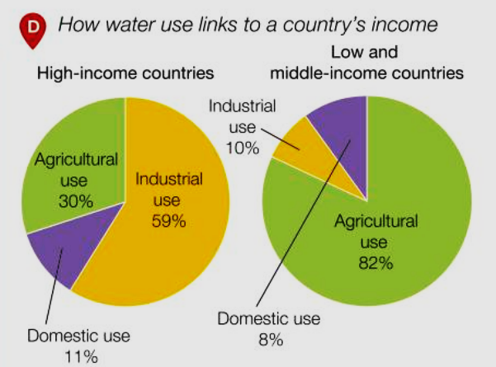
- Why is a good water supply important?
- Why do some countries or world regions have a poor water supply (scarcity)?
- What’s the difference between physical and economic water scarcity?
- Name 5 countries with a physical water scarcity (blue map C).
- Name 5 countries with an economic water scarcity (purple map C) – 1 from each continent.
- How many countries will have a water scarcity issue by 2025?
- STUDY CHART D. How does the water consumption of high and low income countries differ?
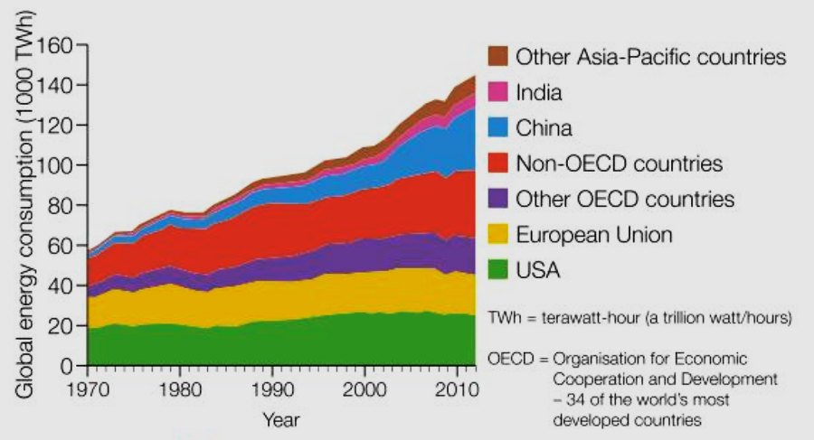
ENERGY
- Why is energy production important for economic development?
- Which region produces most of the world’s oil?
- What are NEEs?
- Why will the demand for global energy increase?
- Describe the trends shown on graph E.

