Where is Rwanda?
Help for Task 1
AC 1.1 and 1.2
https://www.cia.gov/library/publications/the-world-factbook/geos/rw.html
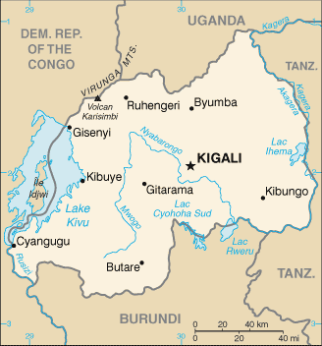
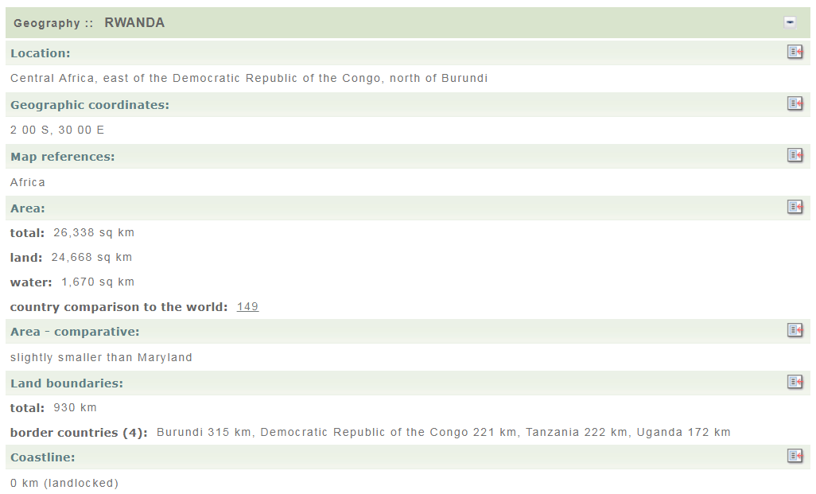
Timeline of Violence
Help for Tasks 2, 3 and 4
AC 1.2, 1.3, 2.1, 2.2, 2.3, 3.1, 3.2
http://www.history.com/topics/rwandan-genocide
From April to July 1994, members of the Hutu ethnic majority in the east-central African nation of Rwanda murdered as many as 800,000 people, mostly of the Tutsi minority. Begun by extreme Hutu nationalists in the capital of Kigali, the genocide spread throughout the country with staggering speed and brutality, as ordinary citizens were incited by local officials and the Hutu Power government to take up arms against their neighbours. By the time the Tutsi-led Rwandese Patriotic Front gained control of the country through a military offensive in early July, hundreds of thousands of Rwandans were dead and many more displaced from their homes. The RPF victory created 2 million more refugees (mainly Hutus) from Rwanda, exacerbating what had already become a full-blown humanitarian crisis.

BACKGROUND: ETHNIC TENSIONS IN RWANDA
By the early 1990s, Rwanda, a small country with an overwhelmingly agricultural economy, had one of the highest population densities in Africa. About 85 percent of its population is Hutu; the rest is Tutsi, along with a small number of Twa, a Pygmy group who were the original inhabitants of Rwanda. Part of German East Africa from 1894 to 1918, Rwanda came under the League of Nations mandate of Belgium after World War I, along with neighbouring Burundi. Rwanda’s colonial period, during which the ruling Belgians favoured the minority Tutsis over the Hutus, exacerbated the tendency of the few to oppress the many, creating a legacy of tension that exploded into violence even before Rwanda gained its independence. A Hutu revolution in 1959 forced as many as 300,000 Tutsis to flee the country, making them an even smaller minority. By early 1961, victorious Hutus had forced Rwanda’s Tutsi monarch into exile and declared the country a republic. After a U.N. referendum that same year, Belgium officially granted independence to Rwanda in July 1962.

Did You Know?
In September 1998, the International Criminal Tribunal for Rwanda (ICTR) issued the first conviction for genocide after a trial, declaring Jean-Paul Akayesu guilty for acts he engaged in and oversaw as mayor of the Rwandan town of Taba.

Ethnically motivated violence continued in the years following independence. In 1973, a military group installed Major General Juvenal Habyarimana, a moderate Hutu, in power. The sole leader of Rwandan government for the next two decades, Habyarimana founded a new political party, the National Revolutionary Movement for Development (NRMD). He was elected president under a new constitution ratified in 1978 and reelected in 1983 and 1988, when he was the sole candidate. In 1990, forces of the Rwandese Patriotic Front (RPF), consisting mostly of Tutsi refugees, invaded Rwanda from Uganda. A ceasefire in these hostilities led to negotiations between the government and the RPF in 1992. In August 1993, Habyarimana signed an agreement at Arusha, Tanzania, calling for the creation of a transition government that would include the RPF. This power-sharing agreement angered Hutu extremists, who would soon take swift and horrible action to prevent it.

GENOCIDE
On April 6, 1994, a plane carrying Habyarimana and Burundi’s president Cyprien Ntaryamira was shot down over Kigali, leaving no survivors. (It has never been conclusively determined who the culprits were. Some have blamed Hutu extremists, while others blamed leaders of the RPF.) Within an hour of the plane crash, the Presidential Guard together with members of the Rwandan armed forces (FAR) and Hutu militia groups known as the Interahamwe (“Those Who Attack Together”) and Impuzamugambi (“Those Who Have the Same Goal”) set up roadblocks and barricades and began slaughtering Tutsis and moderate Hutus with impunity. Among the first victims of the genocide were the moderate Hutu Prime Minister Agathe Uwilingiyimana and her 10 Belgian bodyguards, killed on April 7. This violence created a political vacuum, into which an interim government of extremist Hutu Power leaders from the military high command stepped on April 9.

The mass killings in Rwanda quickly spread from Kigali to the rest of the country, with some 800,000 people slaughtered over the next three months. During this period, local officials and government-sponsored radio stations called on ordinary Rwandan civilians to murder their neighbours. Meanwhile, the RPF resumed fighting, and civil war raged alongside the genocide. By early July, RPF forces had gained control over most of country, including Kigali. In response, more than 2 million people, nearly all Hutus, fled Rwanda, crowding into refugee camps in the Congo (then called Zaire) and other neighbouring countries.

After its victory, the RPF established a coalition government similar to that agreed upon at Arusha, with Pasteur Bizimungu, a Hutu, as president and Paul Kagame, a Tutsi, as vice president and defense minister. Habyarimana’s NRMD party, which had played a key role in organizing the genocide, was outlawed, and a new constitution adopted in 2003 eliminated reference to ethnicity. The new constitution was followed by Kagame’s election to a 10-year term as Rwanda’s president and the country’s first-ever legislative elections.

INTERNATIONAL RESPONSE
As in the case of atrocities committed in the former Yugoslavia around the same time, the international community largely remained on the sidelines during the Rwandan genocide. A U.N. Security Council vote in April 1994 led to the withdrawal of most of a U.N. peacekeeping operation (UNAMIR) created the previous fall to aid with governmental transition under the Arusha accord. As reports of the genocide spread, the Security Council voted in mid-May to supply a more robust force, including more than 5,000 troops. By the time that force arrived in full, however, the genocide had been over for months. In a separate French intervention approved by the U.N., French troops entered Rwanda from Zaire in late June. In the face of the RPF’s rapid advance, they limited their intervention to a “humanitarian zone” set up in southwestern Rwanda, saving tens of thousands of Tutsi lives but also helping some of the genocide’s plotters–allies of the French during the Habyarimana administration–to escape.

In the aftermath of the Rwandan genocide, many prominent figures in the international community lamented the outside world’s general obliviousness to the situation and its failure to act in order to prevent the atrocities from taking place. As former U.N. Secretary-General Boutros Boutros-Ghali told the PBS news program “Frontline”: “The failure of Rwanda is 10 times greater than the failure of Yugoslavia. Because in Yugoslavia the international community was interested, was involved. In Rwanda nobody was interested.” Attempts were later made to rectify this passivity. After the RFP victory, the UNAMIR operation was brought back up to strength; it remained in Rwanda until March 1996, as one of the largest humanitarian relief efforts in history.

In October 1994, the International Criminal Tribunal for Rwanda (ICTR), located in Tanzania, was established as an extension of the International Criminal Tribunal for the former Yugoslavia (ICTY) at The Hague, the first international tribunal since the Nuremburg Trials of 1945-46 and the first with the mandate to prosecute the crime of genocide. In 1995, the ICTR began indicting and trying a number of higher-ranking people for their role in the Rwandan genocide; the process was made more difficult because the whereabouts of many suspects were unknown. The trials continued over the next decade and a half, including the 2008 conviction of three former senior Rwandan defense and military officials for organizing the genocide.

UN failure over Rwanda genocide
Help for Tasks 2 and 3
AC 1.2, 1.3, 2.1, 2.2, 2.3, 3.1
Friday 17 December 1999
http://www.independent.co.uk/news/world/africa/un-pilloried-for-failure-over-rwanda-genocide-739072.html

The United Nations was reeling yesterday after the release of a critical report into its failure to prevent the 1994 genocide in Rwanda that left 800,000 people dead - almost one tenth of the country's population.
The document, compiled by an independent Commission of Inquiry headed by Ingvar Carlsson, the former Swedish Prime Minister, amounts to an astonishing indictment of the UN's response to the crisis. It identifies individuals most closely associated with the serial mistakes and misjudgements, including the UN Secretary-General, Kofi Annan.
The slaughter, which took place over about 100 days and did not even spare those who sought sanctuary in churches and missions, "will forever be remembered as one of the most abhorrent events of the 20thcentury", the document begins. "The international community did not prevent the genocide, nor did it stop the killing once it had begun."
There is equally harsh criticism of the UN Security Council for failing to deploy a sufficient peace-keeping force to the region at the end of 1993 when attempts were made to implement a peace agreement. Among those countries which consistently resisted the formation of a major force was the United States, which had support from Britain. "Those who did not even care, who said that Rwanda was a distant African country and that it is not about us, they must also bear some of the responsibility," Mr Carlsson said. His colleague on the Commission, General Rufus Kupolati of Nigeria, noted that "most of the positions of the United States" during the crisis "were supported by the United Kingdom". Britain eventually contributed logistical support to the peace-keepers, but four months after the slaughter occurred.
Mr Annan, who was in charge of the UN peace-keeping missions at the time, under the then Secretary-General, Boutros Boutros Ghali, was forced to issue a personal apology for the genocide. "All of us must bitterly regret that we did not do more to prevent it," he said in a statement. Mr Annan also said he accepted the report's conclusions, "including those which reflect on officials of the UN Secretariat, of whom I myself was one".
The report describes the failure of the Secretariat, and Mr Annan, to respond to a cable sent on 11 January by the Canadian commander of the peace-keeping mission, General Romeo Dallaire. In it, he said he had intelligence from an informant about plans by Hutu forces for mass extermination of their enemies. He said the plan foresaw Tutsis being killed at the rate of 1,000 every 20 minutes. General Allaire requested permission to take immediate action to intervene and seek out a cache of weapons. The general's proposals were dismissed by Mr Boutros Ghali's chief adviser, Iqbal Riza, but signed by Mr Annan. "It is incomprehensible to the inquiry that not more was done to follow up on the information provided by the informant," the report concludes. The document notes that the spectre of genocide was spelt out in a paper compiled by a rapporteur of the UN Human Rights Commission, Waly Bacre Ndiye, one year earlier, in April 1993, and that it was ignored. It suggests that the peace-keeping department, headed by Mr Annan, was partly at fault.

UN Help Since 1994
Help for Task 4
AC 3.1 and 3.2

http://www.un.org/en/peacekeeping/missions/past/unamirS.htm
At a meeting organized by Rwanda and the United Nations Development Programme in 1996, international donors pledged over $617 million towards the reconstruction of the country. United Nations agencies have continued to provide humanitarian aid and to assist in the return of the refugees.
On 8 November 1994, the Security Council established the International Tribunal for Rwanda "for the sole purpose of prosecuting persons responsible for genocide and other serious violations of international humanitarian law committed in the territory of Rwanda and Rwandan citizens responsible for genocide and other such violations committed in the territory of neighbouring States, between 1 January 1994 and 31 December 1994". Located in Arusha, Tanzania, the Tribunal issued the first indictments in 1995 and held the first trials in 1997.

GACACA TRIALS
Help for Task 4
AC 3.1 and 3.2

BBC News - http://www.bbc.co.uk/news/world-africa-18490348
Rwanda 'gacaca' genocide courts finish work
18 June 2012

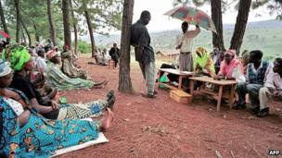
A genocide suspect stands under a tree that acts as a gacaca court

Rwanda's traditional gacaca courts have been controversial
Rwanda's community courts, known as gacaca, have finished their work, after 10 years of trying those accused of involvement in the 1994 genocide.
The courts were set up to speed up the prosecution of hundreds of thousands of genocide suspects awaiting trial.
Human rights group say the gacaca fell well short of international legal standards.
About 65% of the close to two million people tried have been found guilty, according to latest government figures.
Controversial justice
Rwanda's legal system was left in ruins after the massacres by ethnic Hutu militia and soldiers of some 800,000 minority Tutsis and politically moderate Hutus in 100 days between April and June 1994.
The UN's International Criminal Tribunal for Rwanda was set up in neighbouring Tanzania to try the ringleaders of the genocide - it has convicted 54 people and acquitted eight so far. It is due to be closed down at the end of the year.
But this left hundreds of thousands of people accused of involvement in the killings, leading to an enormous backlog of cases in Rwanda.
Correspondents say up to 10,000 people died in prison before they could be brought to justice.
Survivors are worried about their security because they are living side by side with those who had wanted to previously exterminate them
Albert Gasake, Survivors' Fund Organisation
Community courts were set up to clear the backlog - and once a week the so-called gacaca met in villages across the country, often outdoors in a marketplace or under a tree.
The BBC's Prudent Nsengiyumva in the Rwandan capital, Kigali, says one of the main aims of the gacaca was to achieve truth, justice and reconciliation among Rwandans. Gacaca means to sit down and discuss an issue.
The hearings gave communities a chance to face the accused and give evidence about what really happened and how it happened.
Our correspondent says many people in Rwanda say this process have helped to mend the wounds of the past.
But the use of traditional grassroots courts to try complex genocide cases was also controversial - previously the gacaca had only been used to settle local disputes.
More than 160,000 judges were elected from among communities - but they lacked legal qualifications.
The Rwandan government says about two million people went through the gacaca system - final official figures about how many were found guilty are yet to be released, but data from two years ago points to a conviction rate of about 65%.
Some of those found guilty have been sentenced to long jail sentences, with hard labour.
Others have been released and sent back to help rebuild communities - and this has brought its own problems, legal experts say.
"Survivors are worried about their security because they are living side by side with those who had wanted to previously exterminate them," Albert Gasake, the Legal Advocacy Project Coordinator at the Survivors' Fund Organisation told the BBC's Network Africa programme.
"Suspicion is very high," Mr Gasake said.
He also says failure to compensate survivors for the loss of their properties poses another threat to genuine reconciliation.
Our reporter says most Rwandans do not openly criticise the gacaca system.
But local and international human rights groups have expressed concern about its fairness because trials were held without defendants having access to qualified lawyers.
The courts' closure leaves many unanswered questions, our correspondent says.
Human rights groups are asking why some members of the ruling RPF party never had to face the gacaca courts.

Kigali Genocide Memorial
Task 4
AC 3.1 and 3.2
http://www.genocidearchiverwanda.org.rw/index.php/Kigali_Genocide_Memorial
In 2001, in collaboration with Rwanda’s National Commission for the Fight Against Genocide (CNLG), the Aegis Trust raised the $2 million required to build the Kigali Genocide Memorial. The centre was officially opened on 7 April 2004 to mark the tenth commemoration of the 1994 genocide against the Tutsi in Rwanda. The memorial is the final resting place for up to 259,000 victims of the genocide and serves as a place where people can grieve for their lost loved ones and remember them. It also serves as a museum where both local and international visitors can learn about the history, implementation and consequences of the genocide.
Exhibitions
The Kigali Genocide Memorial includes three permanent exhibitions, the largest of which documents the 1994 Genocide against the Tutsi. There is also a children’s memorial and an exhibition on the history of genocidal violence around the world. The Education Centre, Gardens, and Genocide Archive of Rwanda form part of a meaningful tribute to those who perished, and provide a powerful educational tool for visitors.
Visitor Information
The Kigali Genocide Memorial welcomes visitors seven days a week, however on the last Saturday of every month, the memorial is open from 1:00pm to 5:00pm due to Umuganda, when all Rwandans meet to undertake community work.
Education
The Kigali Genocide Memorial is an important place of remembrance and learning about the Genocide against the Tutsi. It is through education that we can prevent mass atrocities from occurring in our communities. A number of education programmes are run by the memorial, both onsite and in communities across Rwanda
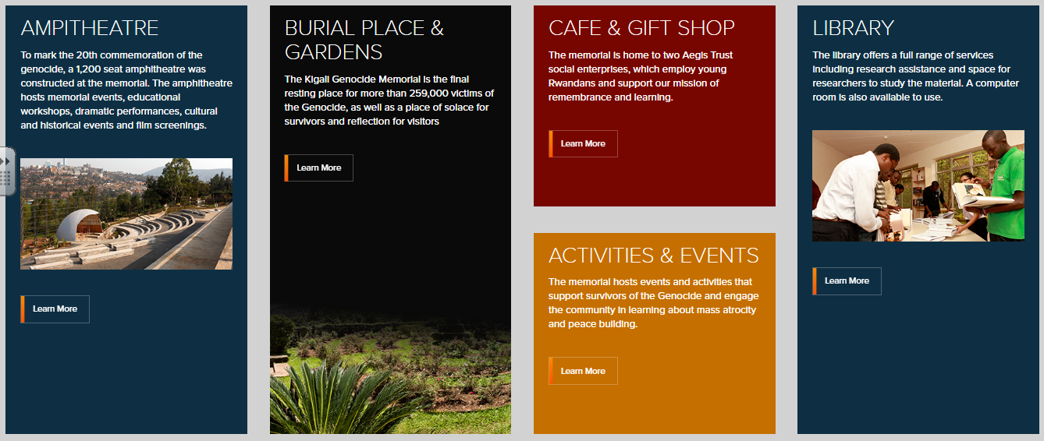
Development before, during and after the conflict
AC 2.3 and 3.2
Use this information as evidence to show the consequences of conflict and show that Rwanda has improved
