Exploring Nigeria P218-221
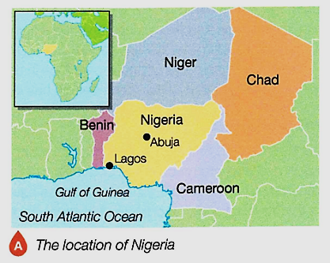
Where is Nigeria?
- Continent _________________________________________
- Neighbours _________________________________________
- Time-zone _________________________________________
- Latitude _________________________________________
- Climatic Zone _________________________________________
Why is Nigeria globally important? Produce a spider diagram summarising its global importance.

Why is Nigeria important to Africa? Produce a spider diagram summarising its African importance.

Political Context – Produce a timeline summarising the information on paragraph 1 of p220.
African map drawn up by European colonisers in 1883.

Nigeria wins independence from the UK in 1960.
1880 | 1900 | 1920 | 1940 | 1960 | 1980 | 2000 | 2020

Produce 3 spider diagrams summarising the society, culture and enviroment. (p220-21)
Nigerian film industry bigger than the US.
Cultural Context
High temperatures and rainfall in south help cocoa, palm oil and rubber growth.
Inequality sparked religious and ethnic conflict
Environmental Context
Social Context
Describe the 5 groups that Nigeria is politically linked to (p222-23).
- ECOWAS _____________________________________________________________________________
- CEN-SAD ____________________________________________________________________________
- OPEC ________________________________________________________________________________
- United Nations _______________________________________________________________________
- African Union ________________________________________________________________________

Name the 5 main countries that Nigeria imports (buys) from and exports (sells) to.
Is crude oil and farm produce a primary or secondary resource?
Exports
- ______________
- INDIA
- ______________
- BRAZIL
- ______________
Imports
- CHINA
- ______________
- ______________
- INDIA
- ______________

What is crude oil?
____________________________________________________________________________________________
Who does Nigeria export it to?
____________________________________________________________________________________________
Why does oil dominate Nigeria’s exports?
____________________________________________________________________________________________
____________________________________________________________________________________________
What farm (agriculture) produce does Nigeria export and to whom?
____________________________________________________________________________________________
____________________________________________________________________________________________
Industrial Structure p224-25
Industrial structure refers to the percentage of people involved in different economic sectors including primary, secondary, tertiary and quaternary industries.

Describe how Nigeria’s industrial structure has changed in the two pie charts. Complete the missing answers.
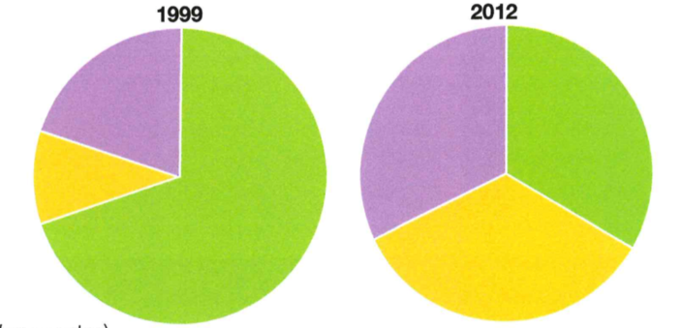
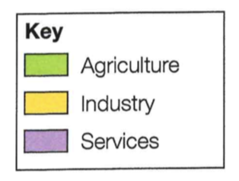

The amount of people working in agriculture ( _______________ ), industry (_______________) and services (_______________)in 2012 was approximately _______________ or 33% each. The number of people working in _______________ has fallen from 67% in 1999. The number of people working in industry has increased from 13% in 1999 and those employed in services has increased from approximately _______________ .

SECONDARY – PRIMARY - 20% - 1/3 – AGRICULTURE - TERTIARY

Why is the economy changing / developing? (Refer to mechanisation, stable government, English language, IT & communications.)
_____________________________________________________________________________________________
_____________________________________________________________________________________________
_____________________________________________________________________________________________
_____________________________________________________________________________________________
_____________________________________________________________________________________________
_____________________________________________________________________________________________
_____________________________________________________________________________________________

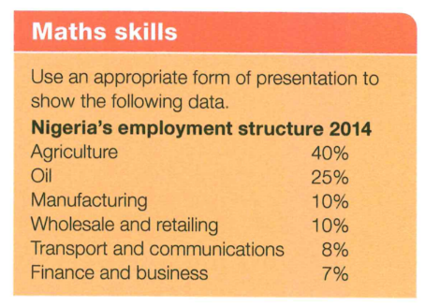
You could choose a pie chart like those above. However,
- Have a go at a stacked bar below. (eg Oil would reach 65% ie 40+25)
- Each block represents 10%.
- Label each 10%.
- Add a key and colour each sector.

Manufacturing (Secondary Sector) Growth p225
How is manufacturing change helping to improve Nigeria’s economy? (Refer to the spin-off industries and jobs as the multiplier effect.)

_____________________________________________________________________________________________
_____________________________________________________________________________________________
_____________________________________________________________________________________________
_____________________________________________________________________________________________
_____________________________________________________________________________________________
_____________________________________________________________________________________________
_____________________________________________________________________________________________

Transnational Corporations (p226-27)
What are transnational corporations? Give four reasons why they locate in LICs or NEEs.

TNCs are… __________________________________________________________________________________
They locate in NEEs like Nigeria for four main reasons;
- ______________________________________
- ______________________________________
- ______________________________________
- ______________________________________

Summarise the main advantages and disadvantages of TNCs. Include examples from the Shell and Unilever case studies.

Disadvantages of TNCs like Unilever & Shell

Advantages of TNCs like Unilever & Shell

Aid in Nigeria (p228-29)
What is the difference between emergency and developmental aid?
_____________________________________________________________________________________________
_____________________________________________________________________________________________
_____________________________________________________________________________________________
_____________________________________________________________________________________________
_____________________________________________________________________________________________
_____________________________________________________________________________________________

Who were the 5 main providers of aid to Nigeria (2014) and how much did they provide?
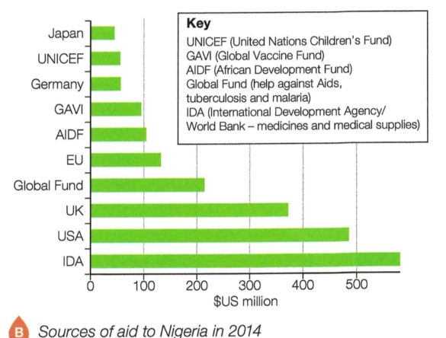
Source:
- The IDA provided $600m
- ________________ provided _______________
- ________________ provided _______________
- ________________ provided _______________
- ________________ provided _______________

What aid does Nigeria receive and why does it get this?
_____________________________________________________________________________________________
_____________________________________________________________________________________________
_____________________________________________________________________________________________
_____________________________________________________________________________________________
_____________________________________________________________________________________________
_____________________________________________________________________________________________

How does aid benefit Nigeria? Use the Aduwan Health Centre case study to help.

Despite the benefits, list 4 reasons why aid is often wasted (not used effectively).
- _______________________________________________________________________
- _______________________________________________________________________
- _______________________________________________________________________
- _______________________________________________________________________

The Environment (p230-31)
Summarise 8 ways in which the environment is threatened by Nigeria’s rapid development.
- ______________________________________________________________________________________
- ______________________________________________________________________________________
- ______________________________________________________________________________________
- ______________________________________________________________________________________
- ______________________________________________________________________________________
- ______________________________________________________________________________________
- ______________________________________________________________________________________
- ______________________________________________________________________________________

How has Shell tried to reduce the impacts from the oil spill in 2008-09?
_____________________________________________________________________________________________
_____________________________________________________________________________________________
_____________________________________________________________________________________________
_____________________________________________________________________________________________
_____________________________________________________________________________________________

Quality of Life? (p232-33)
What is the HDI and how has Nigeria’s HDI changed over time?
_____________________________________________________________________________________________
_____________________________________________________________________________________________
_____________________________________________________________________________________________
_____________________________________________________________________________________________
_____________________________________________________________________________________________

What do you think are the 5 biggest improvements to Nigerians quality of life? (Use photo A and table C to help.)
- ______________________________________________________________________________________
- ______________________________________________________________________________________
- ______________________________________________________________________________________
- ______________________________________________________________________________________
- ______________________________________________________________________________________

What are the three biggest problems that still face Nigerians?
- ______________________________________________________________________________________
- ______________________________________________________________________________________
- ______________________________________________________________________________________

